- As user press Enable PIN.
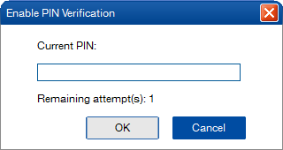
- After enter correct PIN
- Asking to enter PUK after enter wrong PIN 3 times.
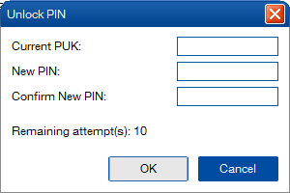
- After press modify PIN
